**Phoenix Windows Application – CAD**

WinAppDriver - The tool used to automate windows applications introduced by windows work similar as Selenium and Appium remote server.

**Prerequisite**:

* Eclipse
* Selenium
* Java
* WinAppDriver
* WinAppDriverUIRecorder
* Windows10 M/c

Phoenix Windows Application framework development documents.

1. **Enable Developer Mode option in Windows 10**

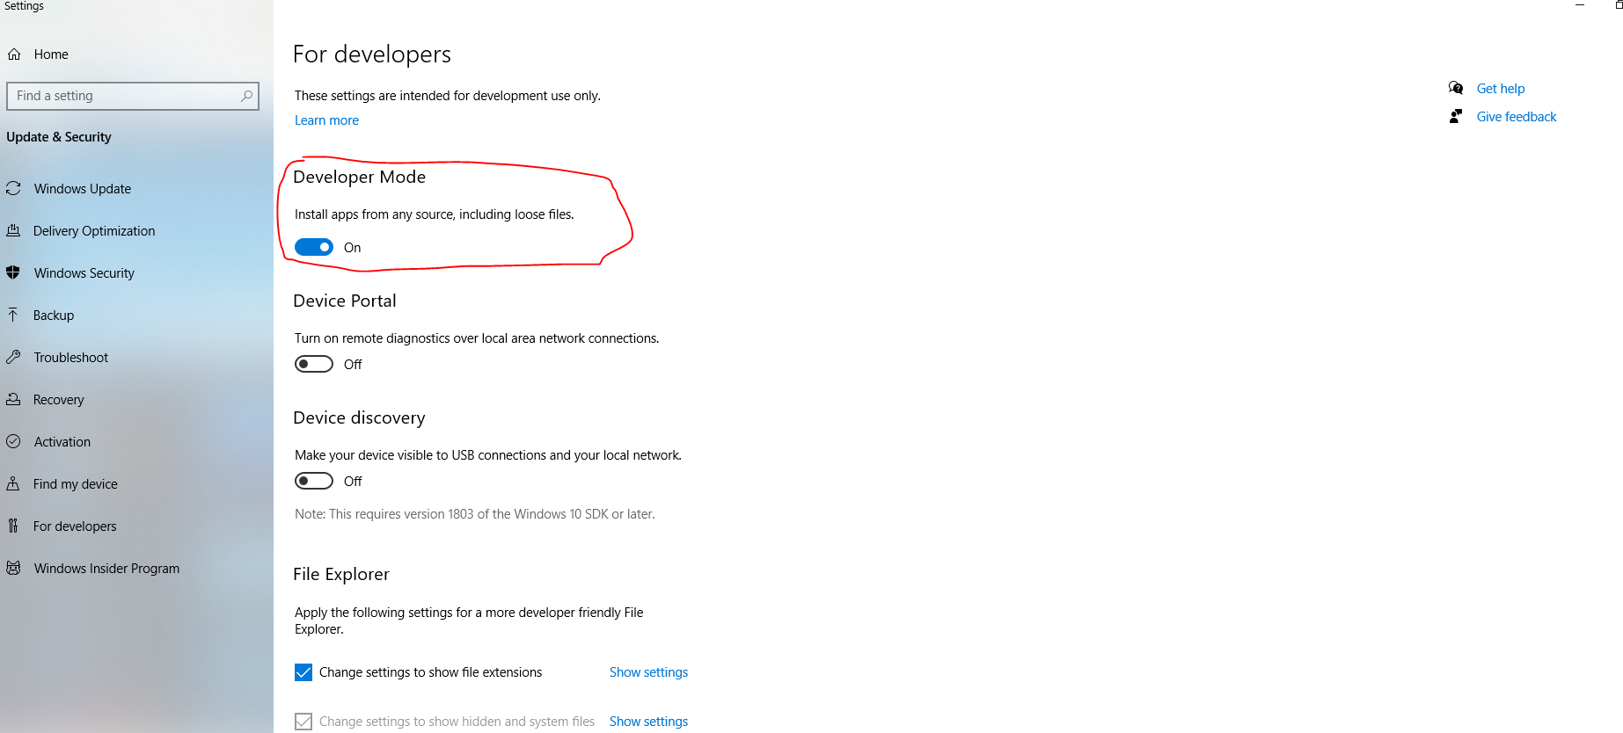

1. **Download WinAppDriver**

url : <https://github.com/microsoft/WinAppDriver/releases/tag/v1.2.1>

Download WinAppDriver in specified path. We can download 32 or 64 bit based on m/c configuration.

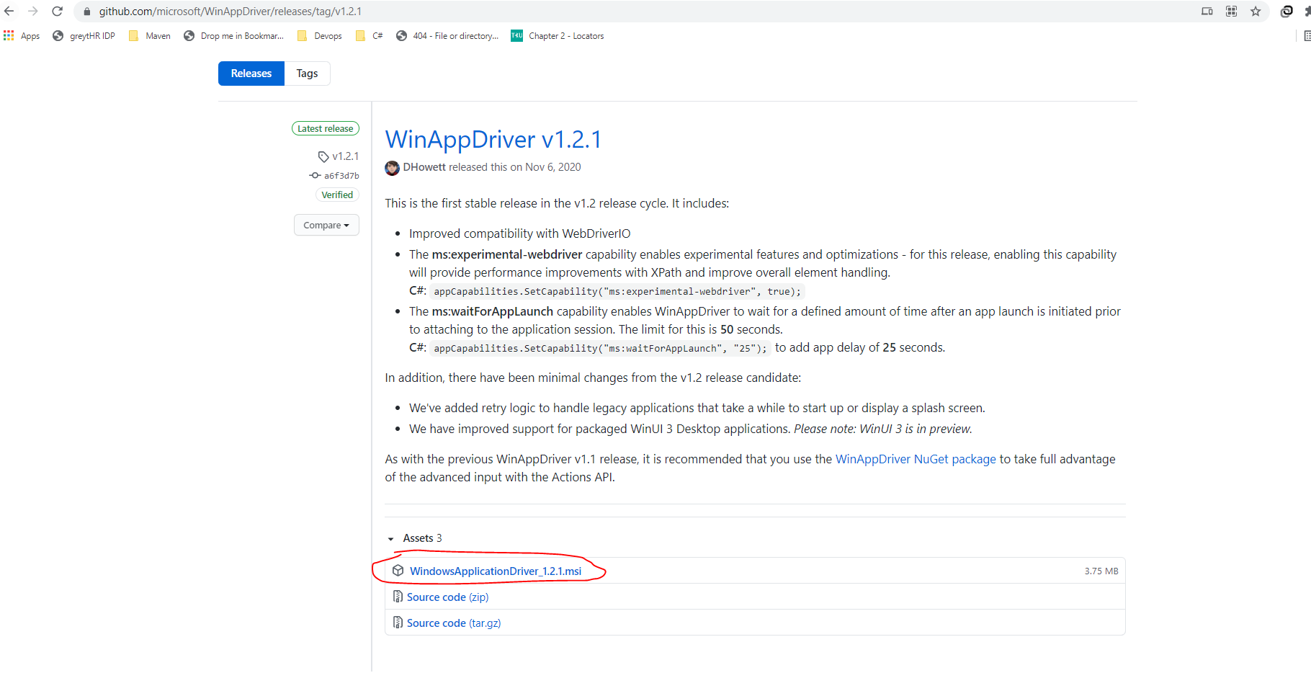

After download WinAppDriver MSI file we want to install driver in local machine

* **Double click MSI file**

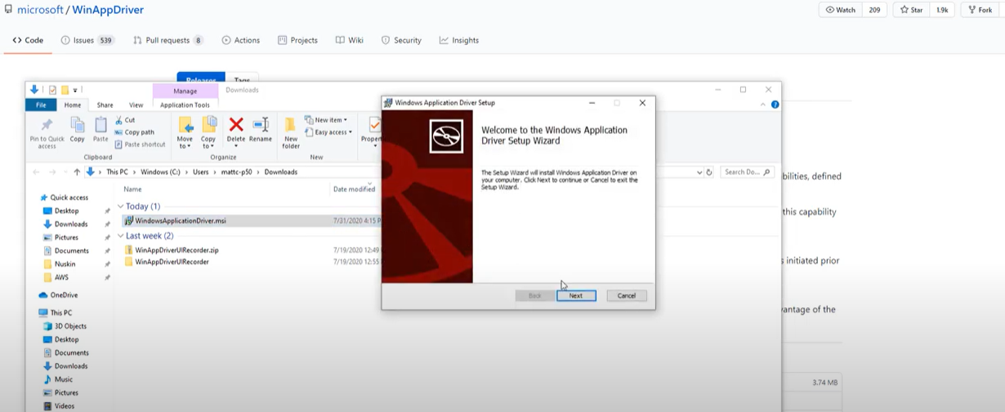

* **Click on License Agreement Checkbox**

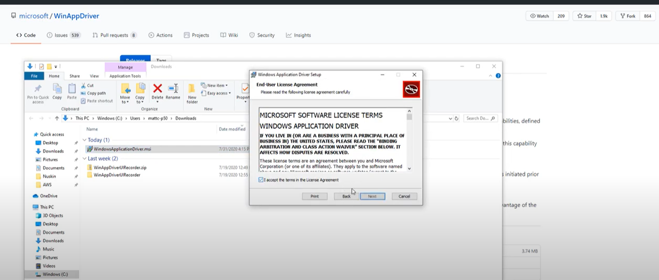

* **Select File Location**

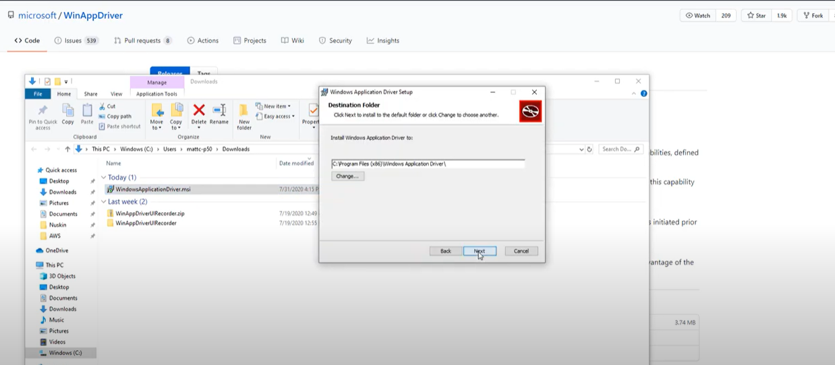

* **Install WinAppDriver**

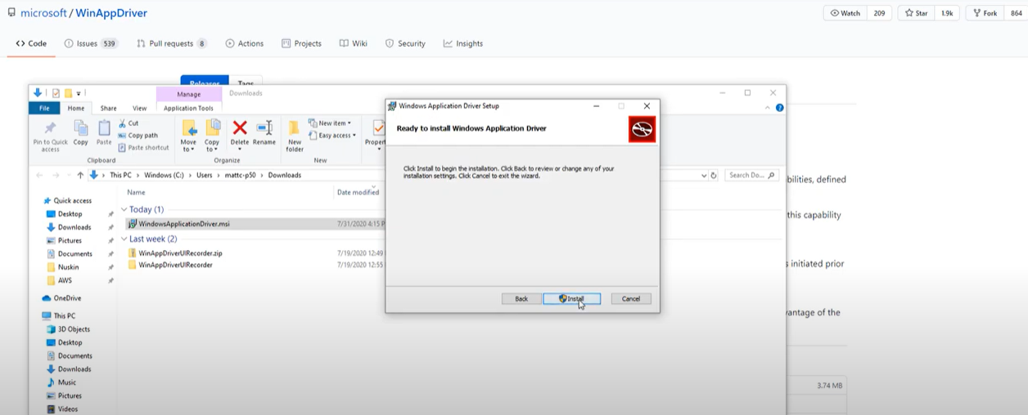

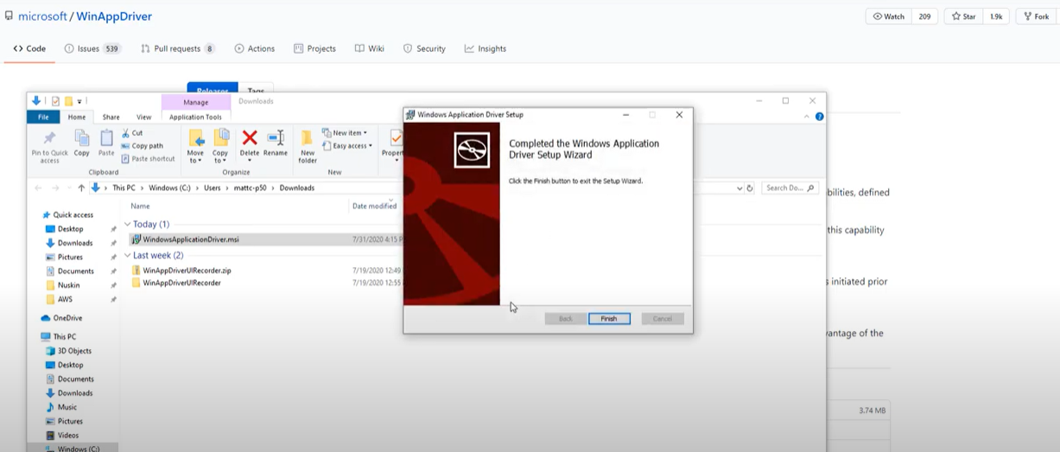

* Once WinAppdriver installed in Desktop, we can access in Start menu.

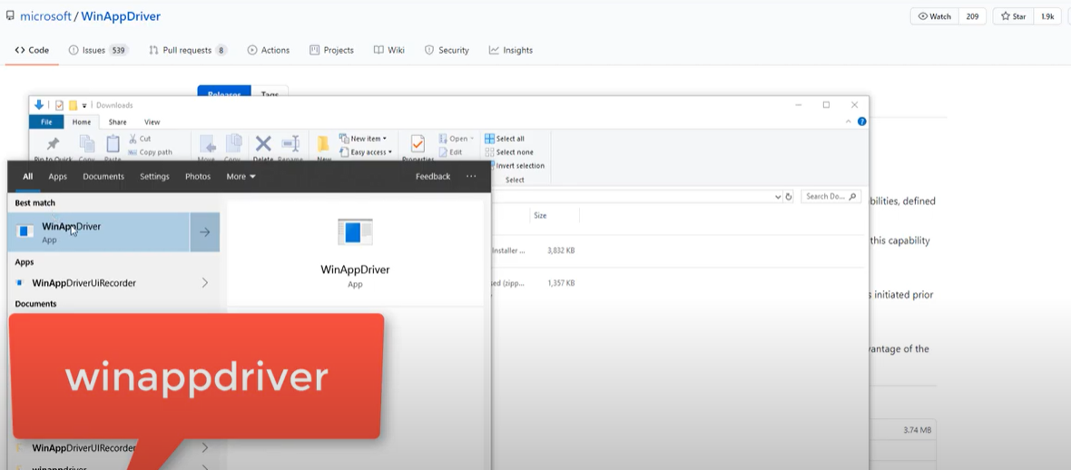

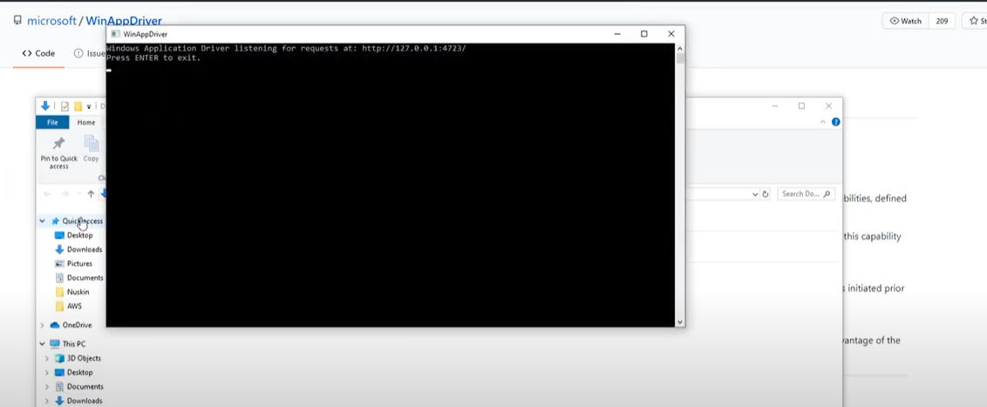

1. **WinAppDriverUIRecorder**

url : <https://github.com/microsoft/WinAppDriver/releases/tag/v1.2.1>

Download WinAppDriverUIRecorder in specified path and Extract in Local machine

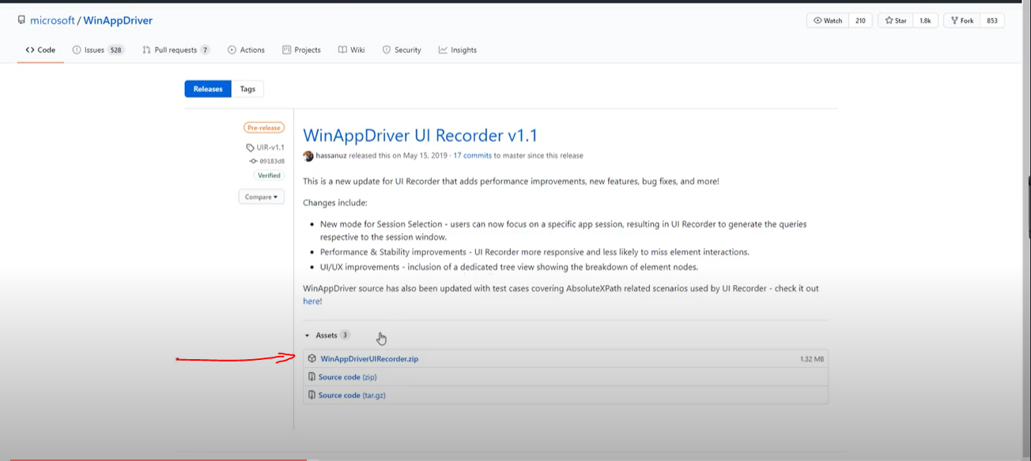

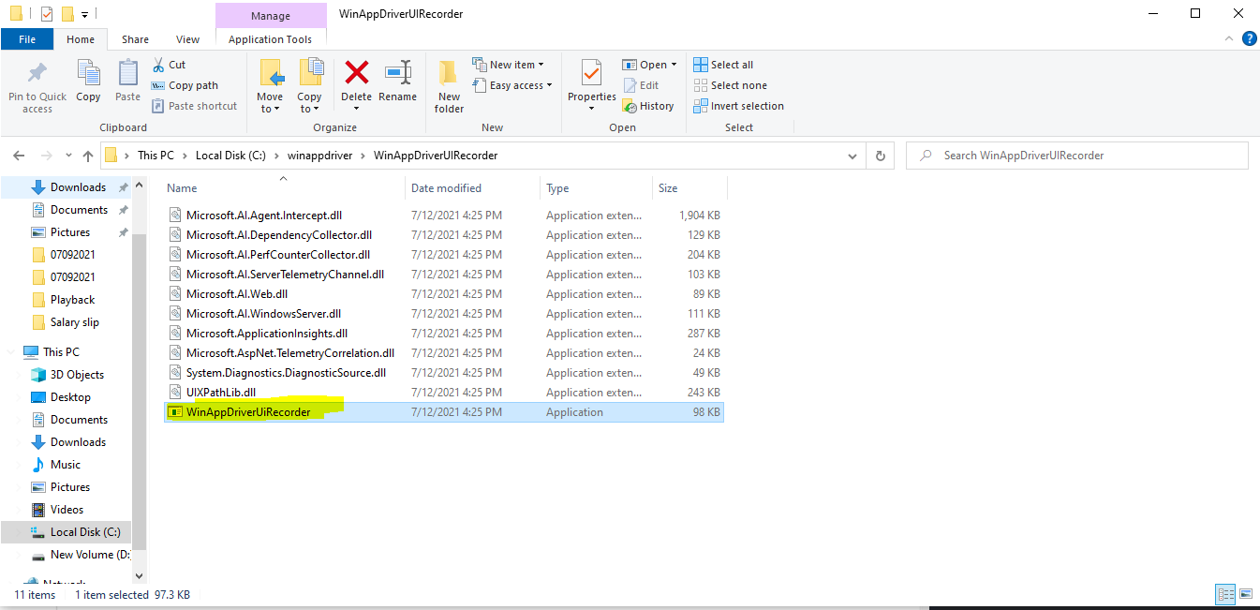

Recorder UI :

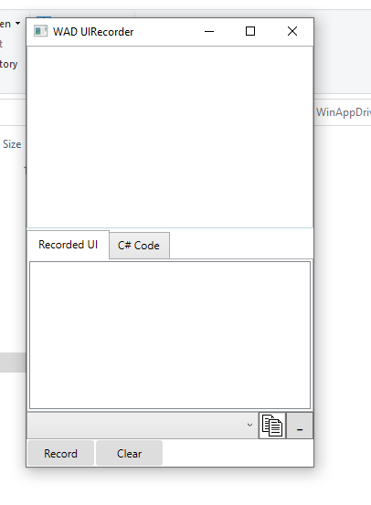

Click on record button, after all windows actions are shows in Recorded UI column

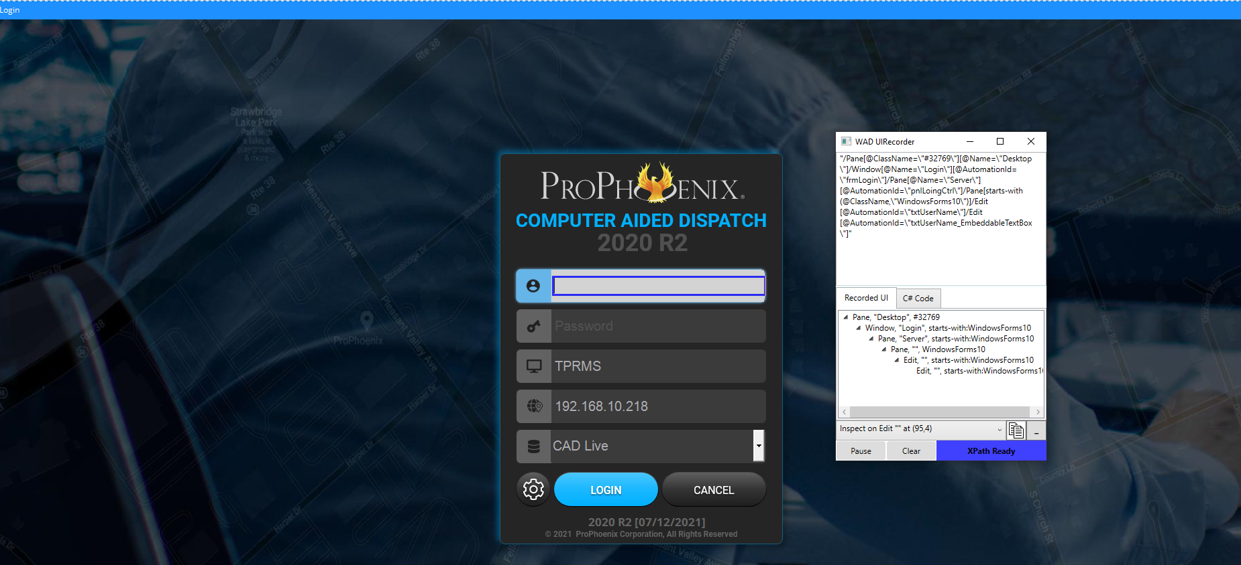

1. **FrameWork Structure:**

We followed Data driven framework with POM design pattern

Driver Class file

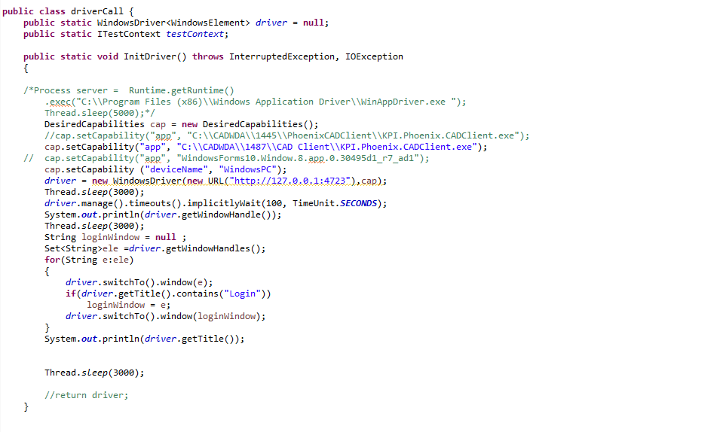

UI Class file

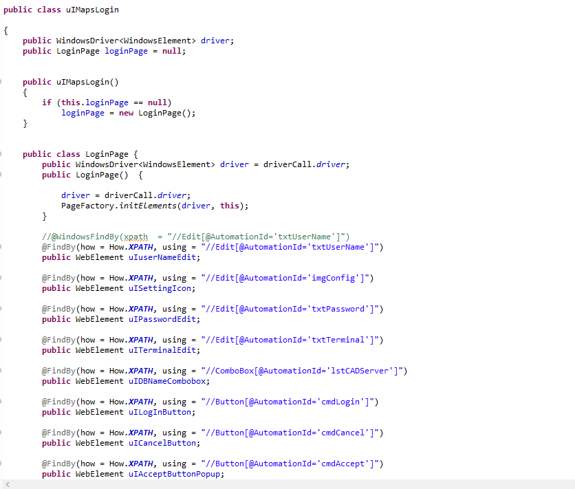

Action Class file

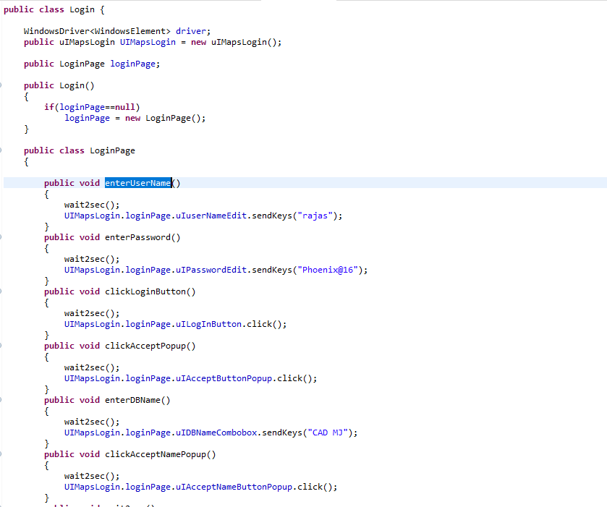

Script class file

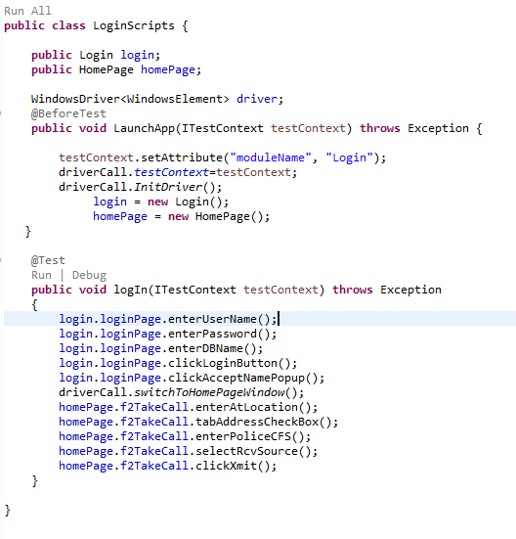

Script running report

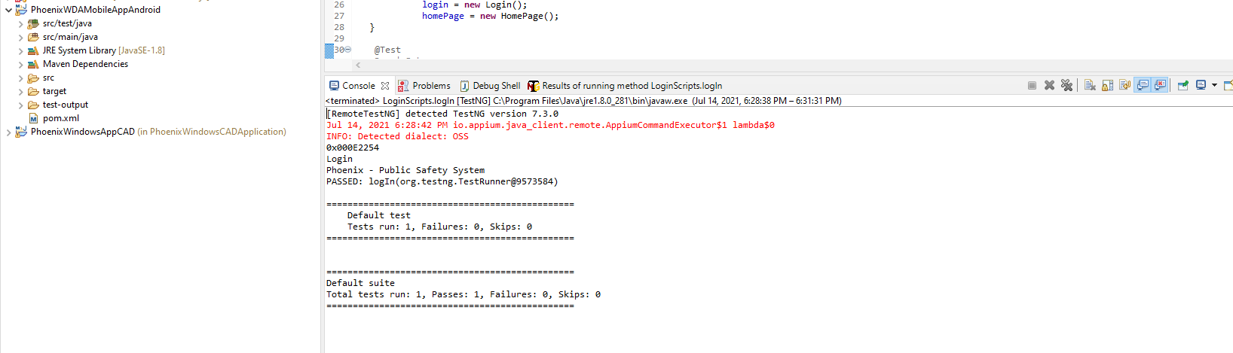

Extent Report

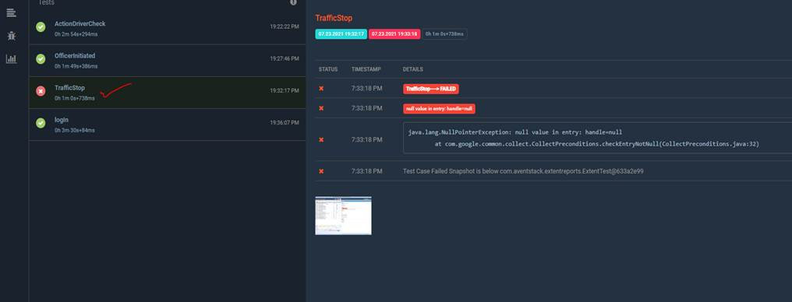

END